[http://localhost:8080/prweb/PRSOAPServlet/SOAP/AIPAPackage/VINValidationService?WSDL](https://www.google.com/url?q=https://www.google.com/url?q%3Dhttp://localhost:8080/prweb/PRServlet/0GDuZMaJ8K7pyWD2vcEBBREyIMFZg7ce*/!PS1__TABTHREAD0?pyActivity%253D%252540baseclass.pzTransformAndRun%2526pzTransactionId%253D3ae03e354096b18641f93c38c78699c9%2526pzFromFrame%253DpyWorkPage%2526pzPrimaryPageName%253DpyNewResults%2526preActivity%253D%2526preActivityParams%253D%2526action%253Ddisplay%2526harnessName%253DRuleForm%2526className%253DData-Admin-ServicePackage%2526pyDataTransform%253D%2526pyPreActivity%253DdoUIAction%2526pzPrimaryPage%253DpyNewResults%2526checkForNewPage%253Dtrue%2526portalName%253DDeveloper%2526contentID%253D_blank%2526readOnlyMode%253Dfalse%2526pzHarnessID%253DHIDEDD051B8DC148CE9AF95D686627EF5D6%26amp;sa%3DD%26amp;source%3Deditors%26amp;ust%3D1620642023535000%26amp;usg%3DAOvVaw0aIqEh0ZA4bi69lZhGBy5U&sa=D&source=editors&ust=1620642023563000&usg=AOvVaw0FxuF36b6DuTPlQzdYbSvY)

=============

**Working with Connect SOAP:**

**Connect SOAP**

**XML Stream**

**Parse XML**

**Connector Activity**

**Req: Consume VIN Validation service to populate VIN Details based VINNO**

**Note: Once we get the WSDL Url, we can run connector & Metadata wizard which will create all the required rules to consume the service.**

**- While Consuming the Service we use Organization Int Layer. Organization Int Layer is already available.**

**Open Connector & Metadata Wizard:**

**Configure-> Integration->  Connectors-> Connector & Metadata Wizard**

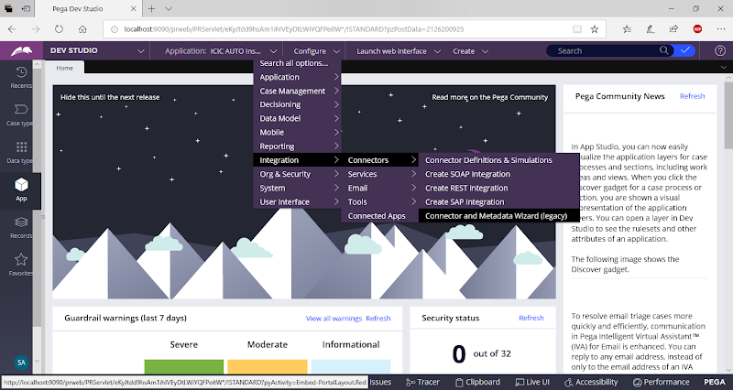

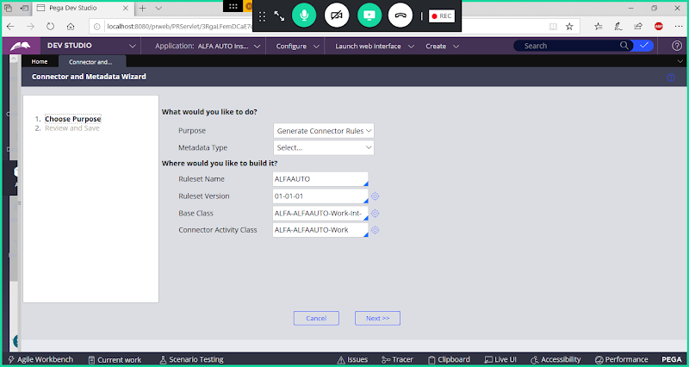

**First Select Metadata Type & Select Latest Ruleset Version:**

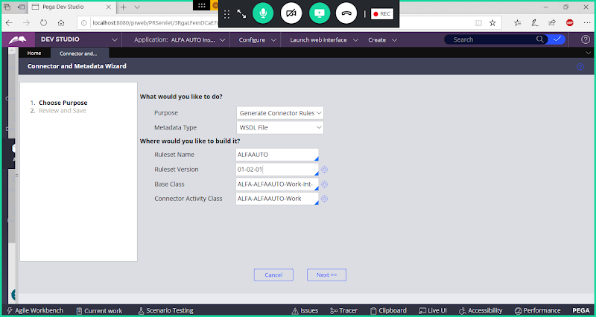

**Change Base Class to Organization int Class: ALFA-Int**

**Update Base Class to Organization Int Class:**

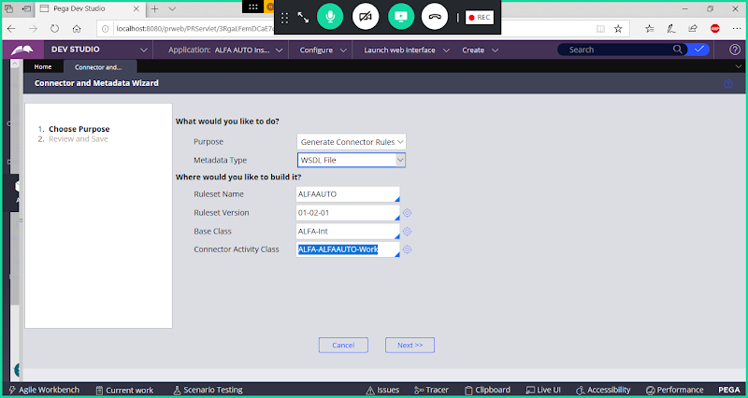

**Next**

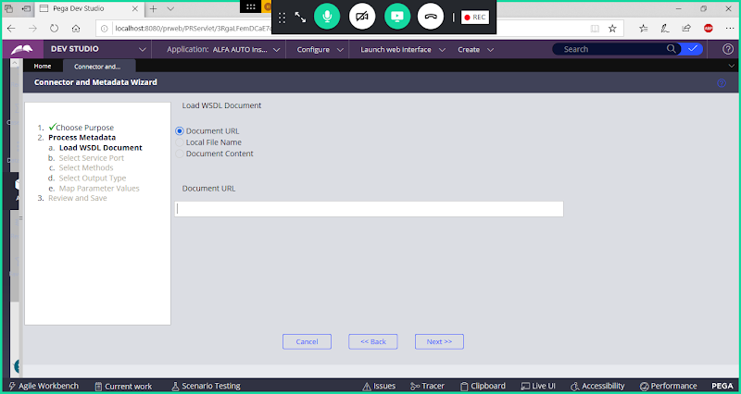

**Copy WSDL Url**

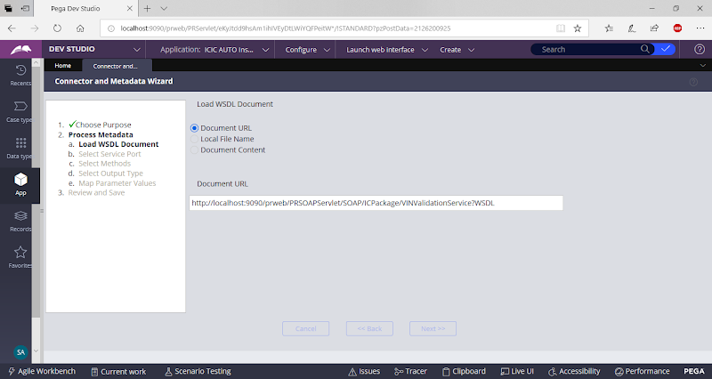

**Next**

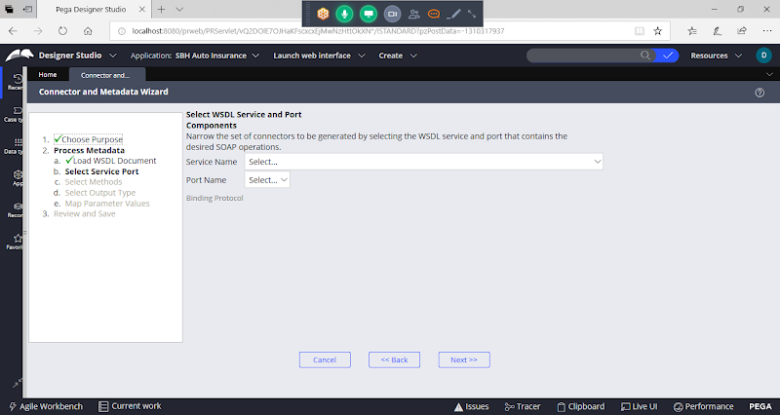

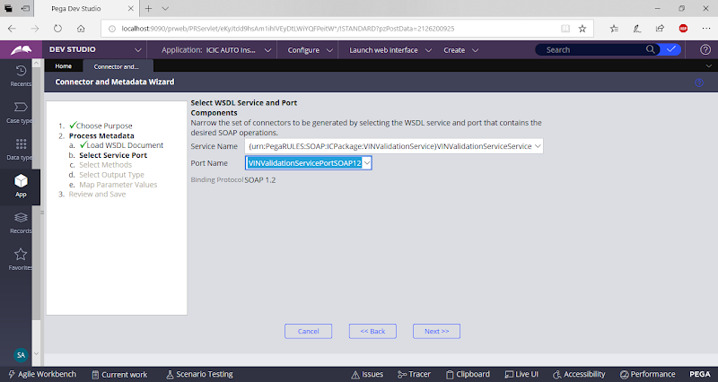

**Next**

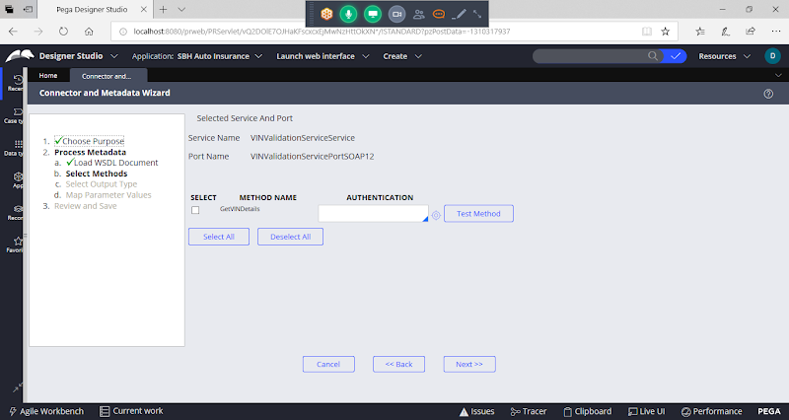

**Select Method**

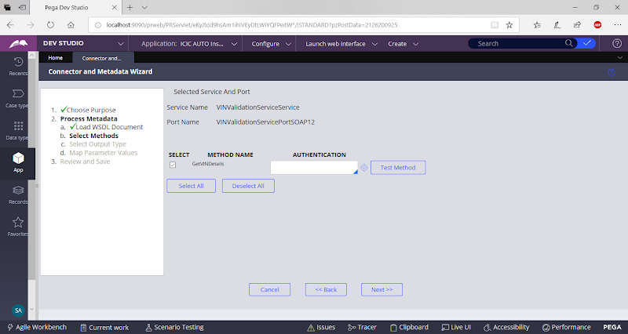

**Next**

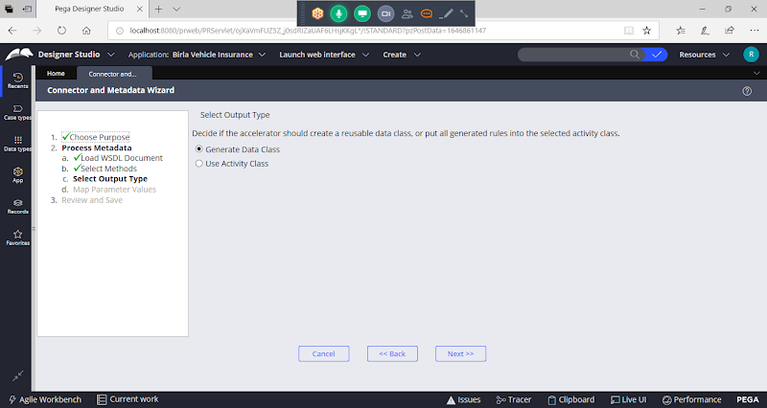

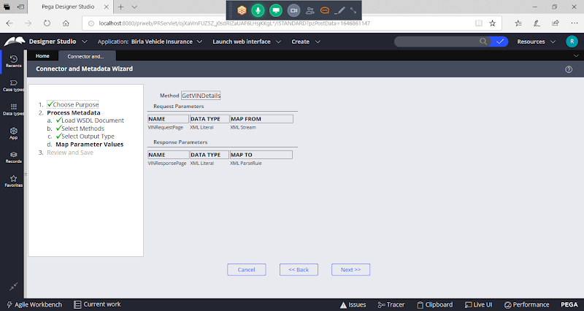

**Next**

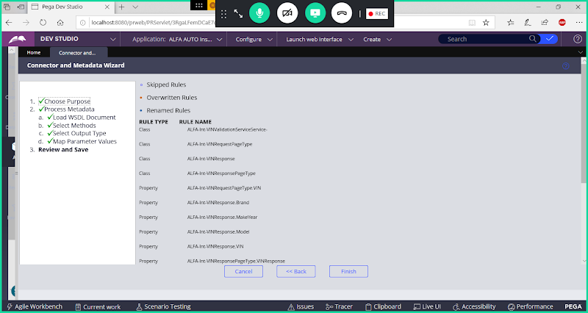

**Finish**

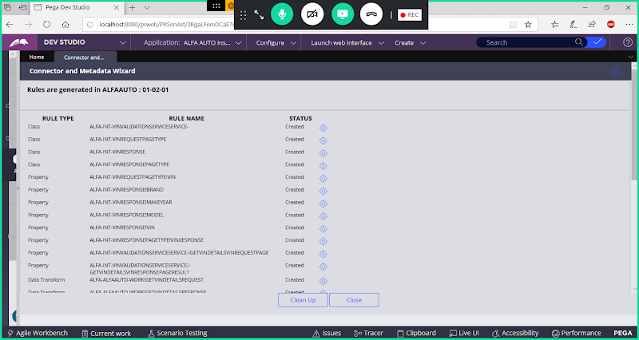

**Click on Close**

**To Check all the Rules we can check under : ALFA-Int**

**Open Activity Rule from Work Class Group:**

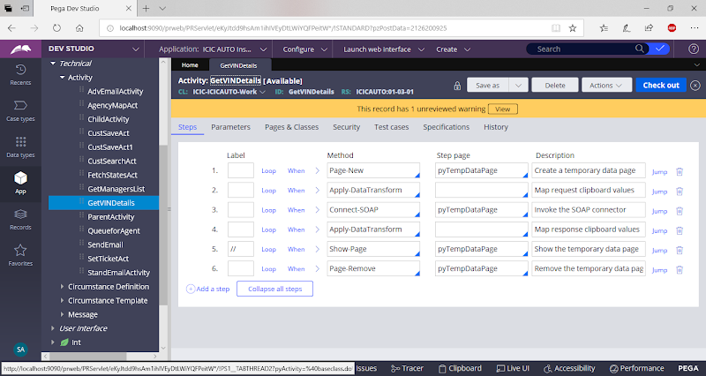

**Here Activity will be created to Call Connect-SOAP**

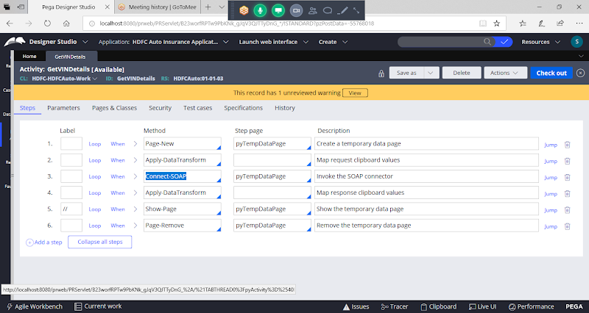

**Update Methods in Activity:**

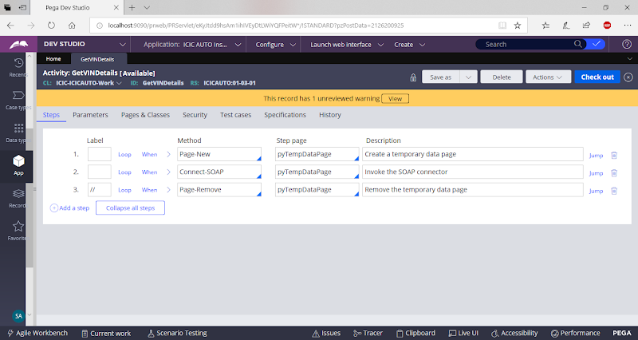

**Go to Parameters Tab in Activity & Delete Default Parameters:**

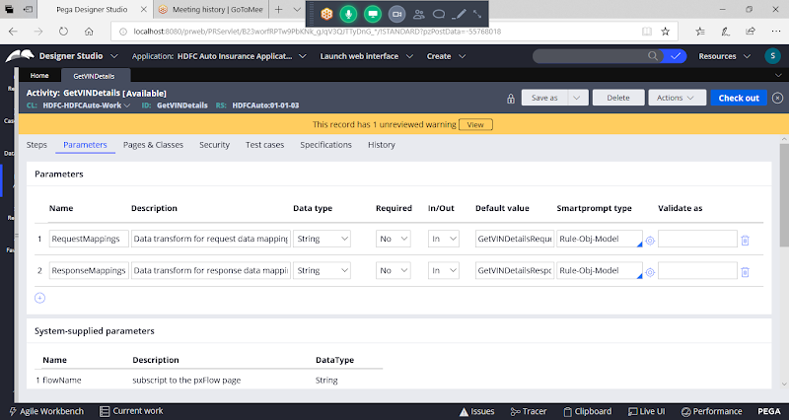

**Delete Parameters:**

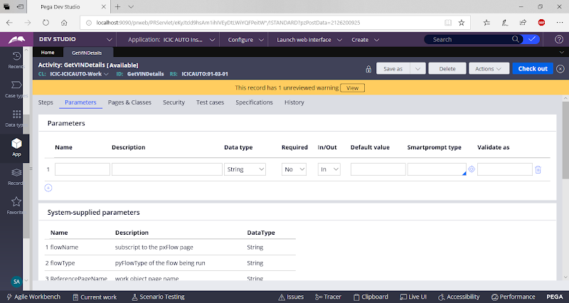

**Now Go to Steps Tab:**

**Before Connect SOAP Methods add New Method to assign input Properties to connector**

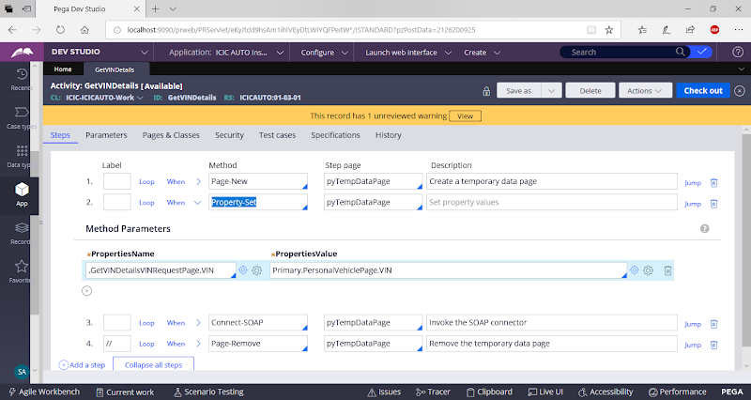

**Now add Property set Method After Connect SOAP to assign Response properties:**

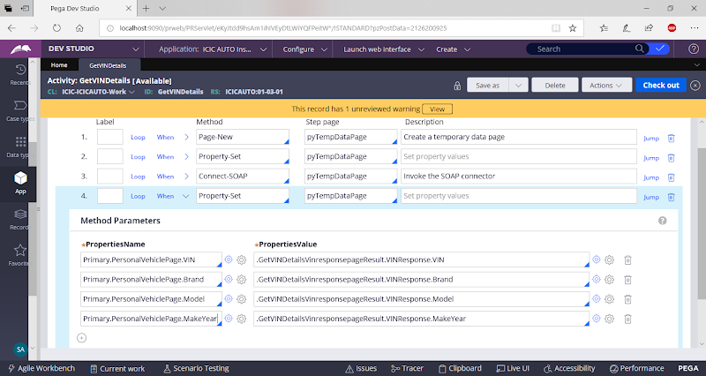

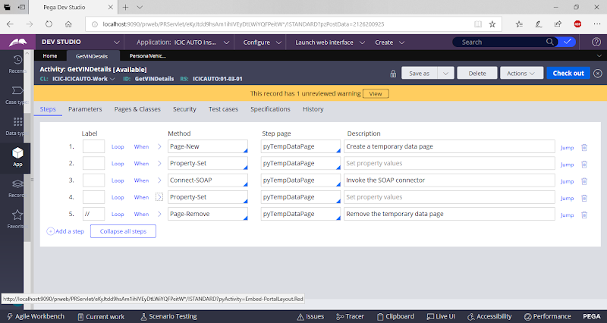

**Save Activity**

**Call this Activity in personal vehicle section on Click of Button.**

**Open Personal Vehicle Section**

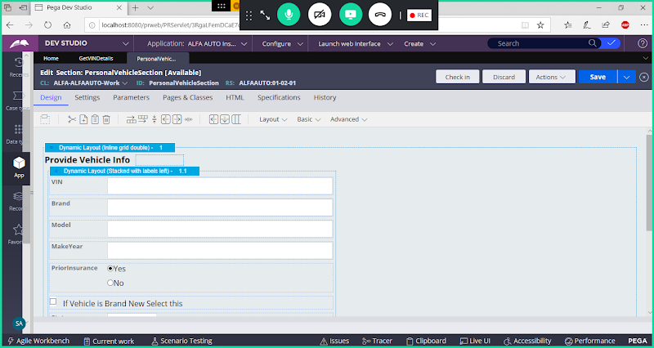

**Add Button & VIN Property**

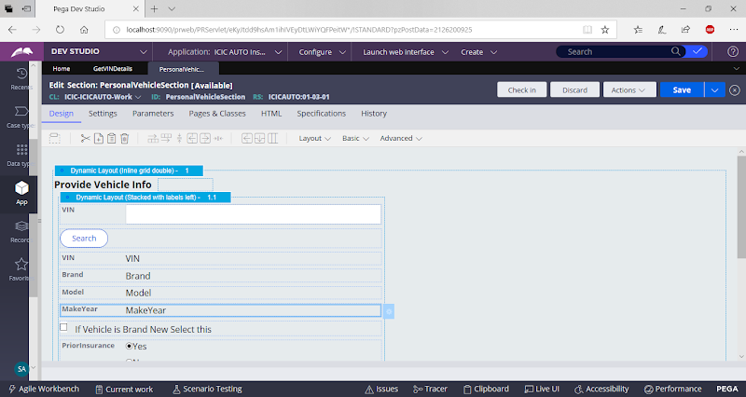

**Give Caption & Call Activity**

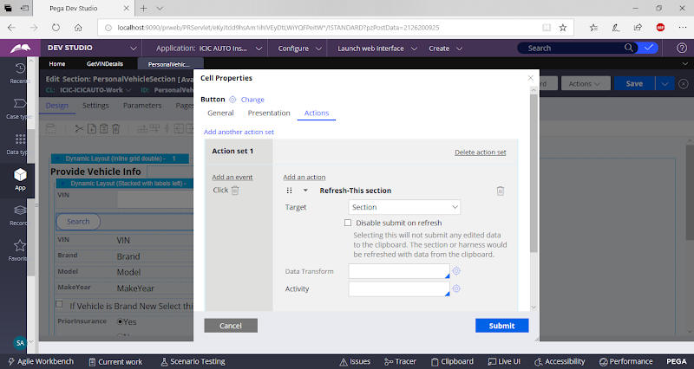

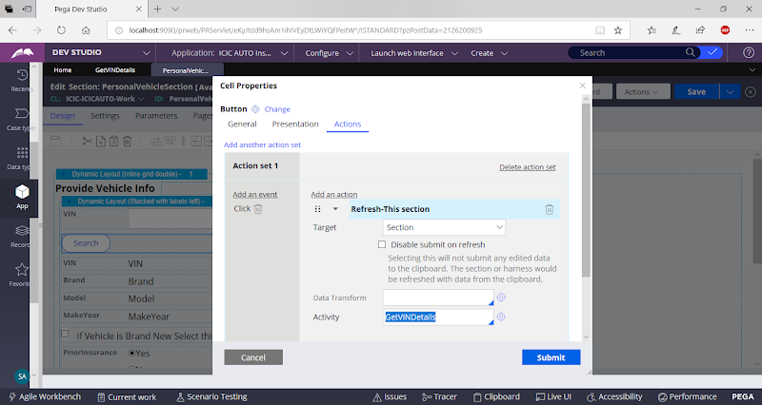

**Submit**

**Set Company, Model & Makeyear fields as ReadOnly Fields.**

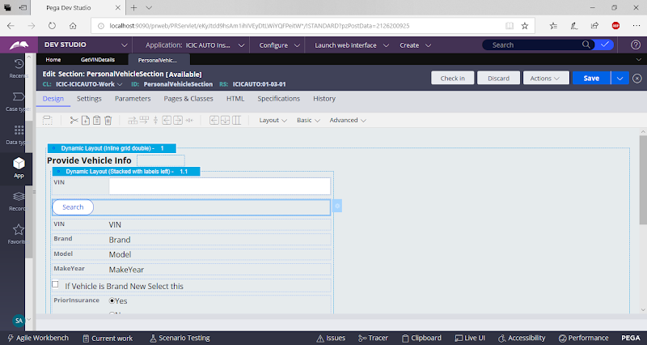

**Save & Check in**

**Execute Insurance Flow**

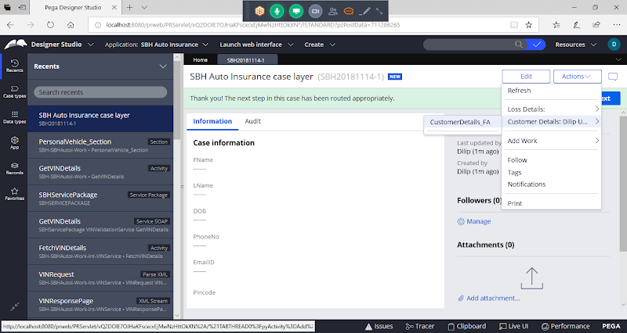

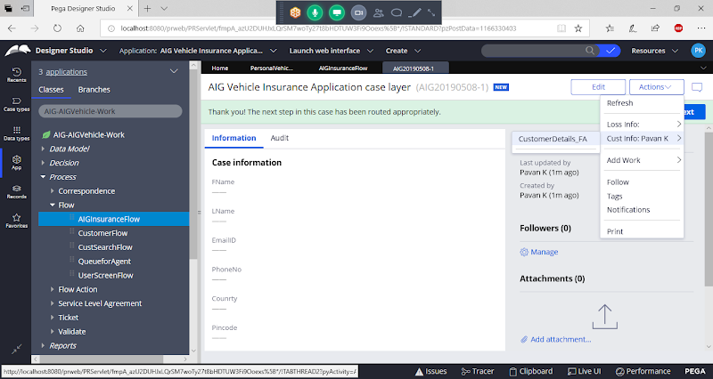

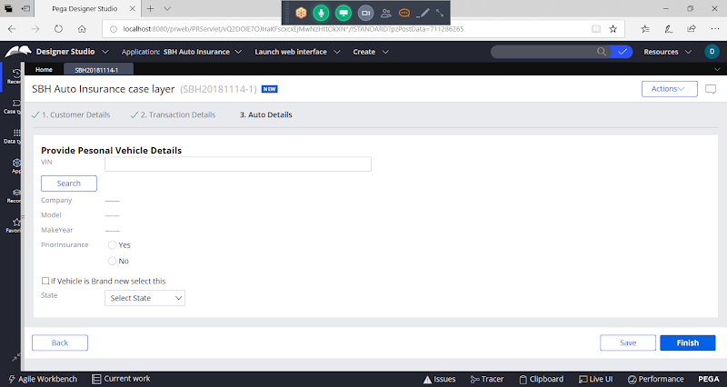

**Give VIN:**

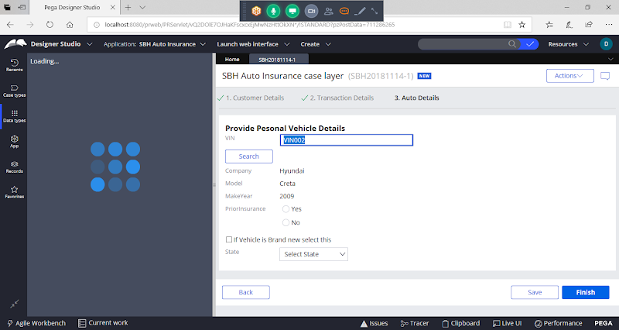

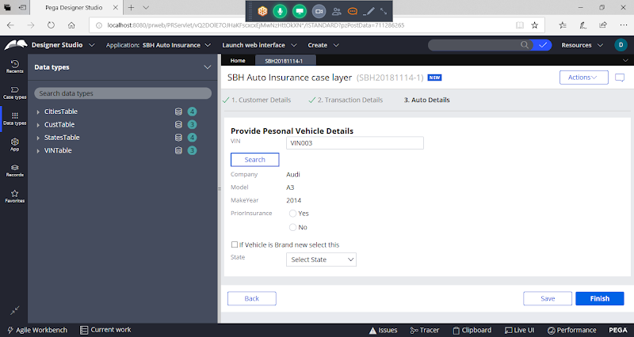

**=============**

**Connector Activities we can call in 2 ways:**

**In Section - Button Settings / in Input Property**

**In Flow - We need to Use Integrator Shape to call Connector Activities**

**Start-----Ass1-----Integrator------Ass2------End**

**==========**

**Connect REST:**

**REST Ful Services:**

**XML**

**JSON : { )**

**groupkt.com**

**http://www.groupkt.com/post/f2129b88/free-restful-web-services-to-consume-and-test.htm**

The url for this web service is:

[http://services.groupkt.com/country/get/iso3code/{alpha3_code](https://www.google.com/url?q=https://www.google.com/url?q%3Dhttp://services.groupkt.com/country/get/iso3code/%25257Balpha3_code%26amp;sa%3DD%26amp;source%3Deditors%26amp;ust%3D1620642023542000%26amp;usg%3DAOvVaw1Z_UbgiQDi6tpu8Yrjhiyj&sa=D&source=editors&ust=1620642023567000&usg=AOvVaw14FobiCjF-35Aay2qwsAl2)}

[http://services.groupkt.com/country/get/iso3code/](https://www.google.com/url?q=https://www.google.com/url?q%3Dhttp://services.groupkt.com/country/get/iso3code/%25257Balpha3_code%26amp;sa%3DD%26amp;source%3Deditors%26amp;ust%3D1620642023543000%26amp;usg%3DAOvVaw14WI4Pny6JyVFUbvz0GpIT&sa=D&source=editors&ust=1620642023567000&usg=AOvVaw2jhmSYnB0IhZmL-byUuy55)IND

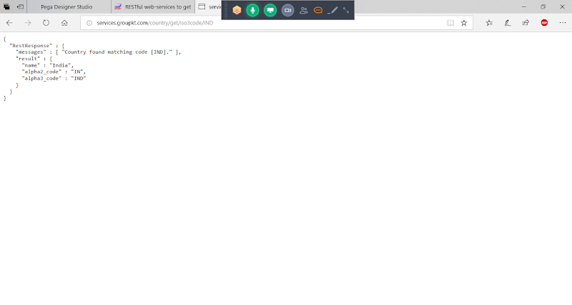

**Connect - REST:**

**Creating REST Integration:**

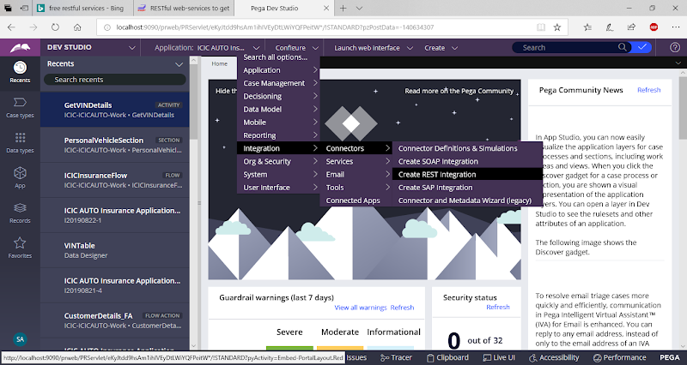

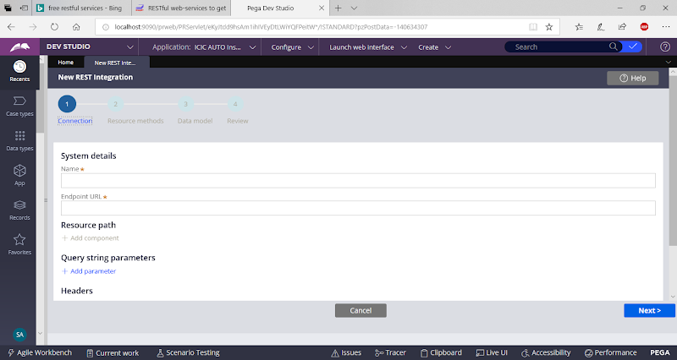

[http://services.groupkt.com/country/get/iso3code/{alpha3_code](https://www.google.com/url?q=https://www.google.com/url?q%3Dhttp://services.groupkt.com/country/get/iso3code/%25257Balpha3_code%26amp;sa%3DD%26amp;source%3Deditors%26amp;ust%3D1620642023544000%26amp;usg%3DAOvVaw0bCUX5CxmJezCb9pvbhtZF&sa=D&source=editors&ust=1620642023567000&usg=AOvVaw3NGruJ185jJNqk0rJ7nAeG)}

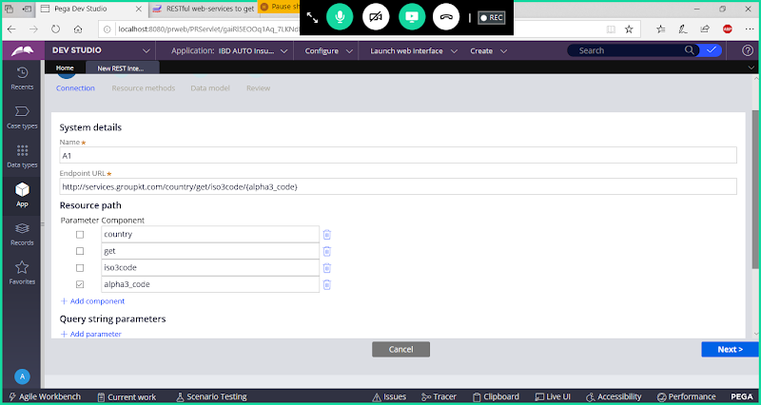

**Next**

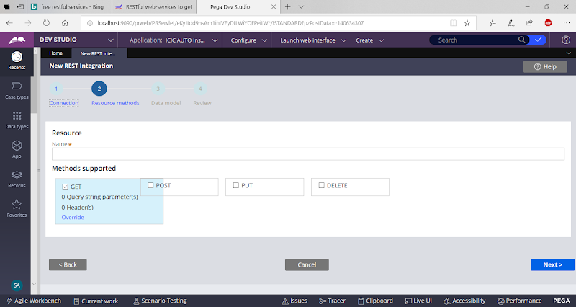

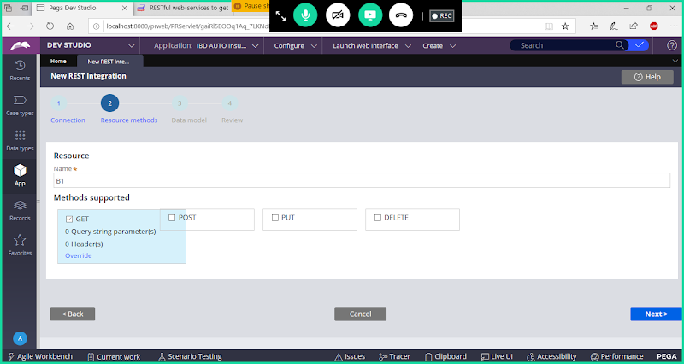

**Next**

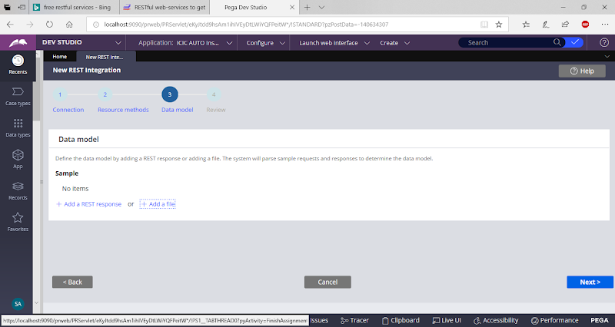

**Add Rest Response ( Means adding Respoonse Properties- Use Add a File)**

**Add a file**

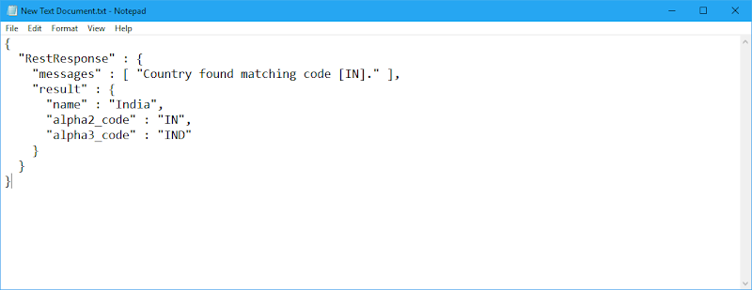

**Copy Rest Response:**

**Click on Add a File->**

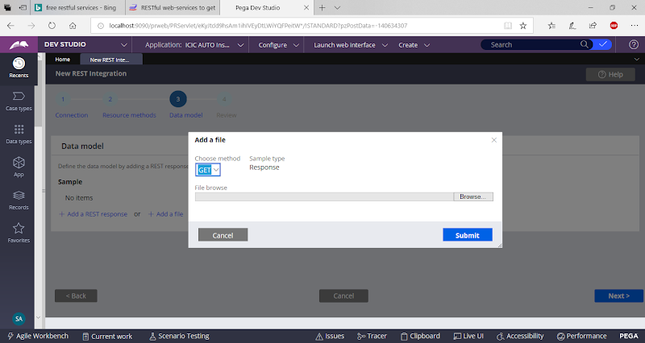

**Browse**

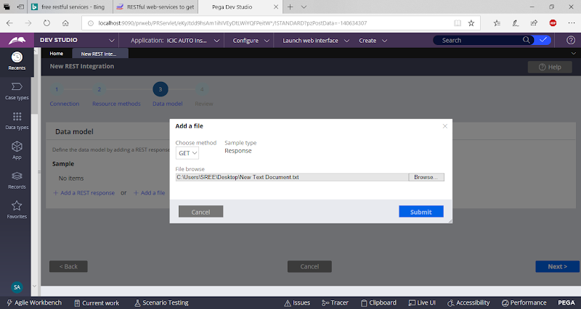

**Submit**

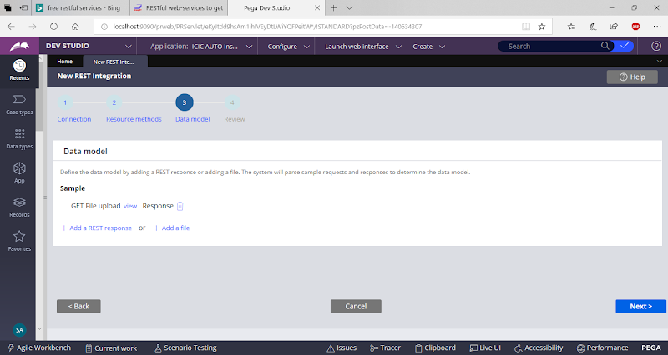

**or  Add Rest Response Automatically**

**Click on Add a Rest Response**

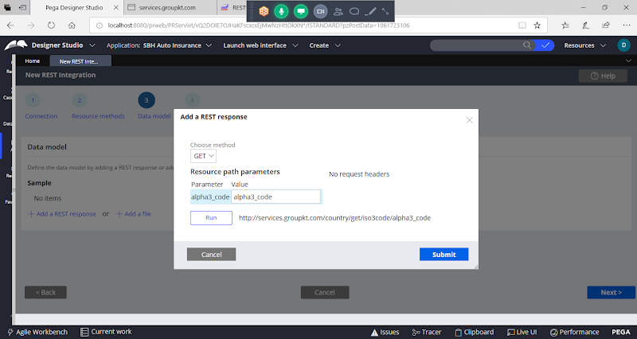

**Give Value: IND**

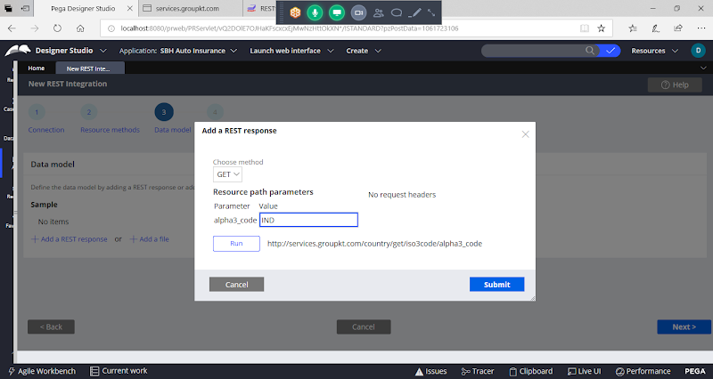

**Click on Run**

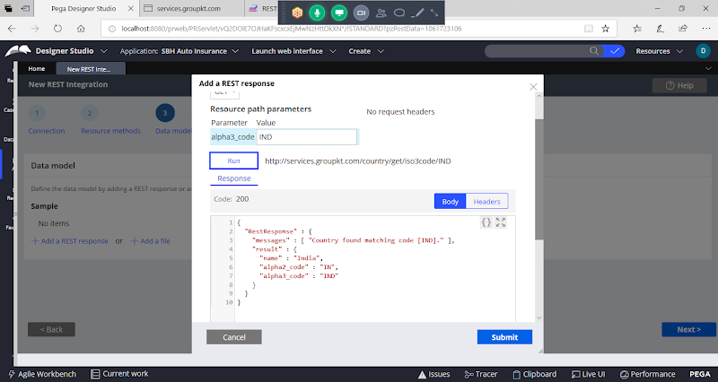

**Click on Submit**



**Next**

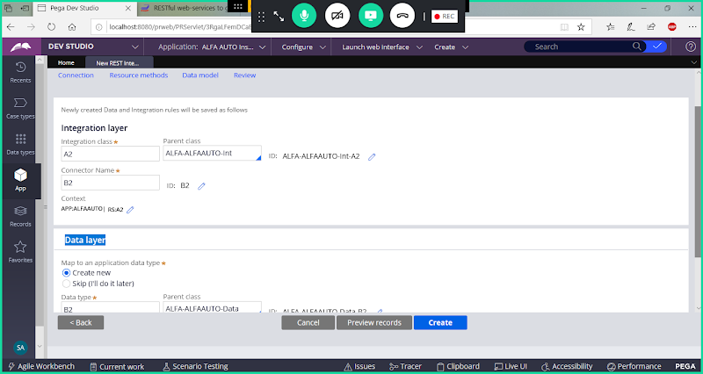

**Click on Create**

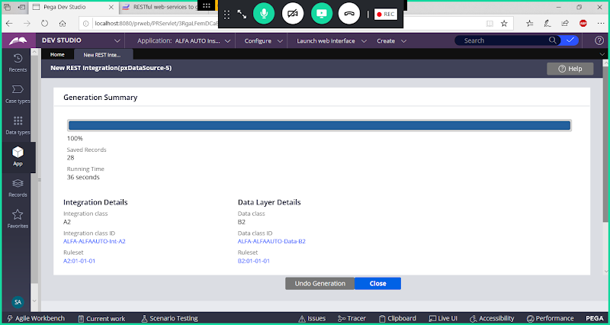

**Open Data Page**

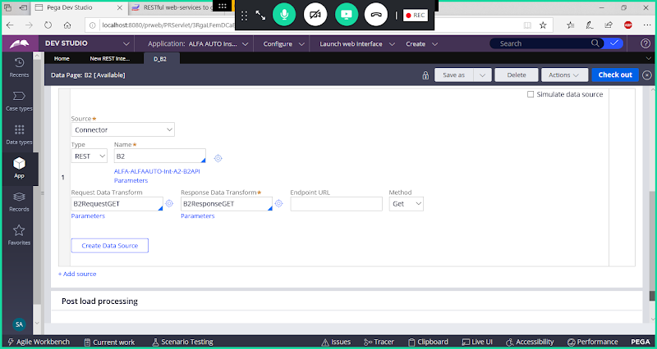

**Click on Close**